2022 Water Quality Report for City of Onaway
Water Supply Serial Number: 05010
This report covers the drinking water quality for City of Onaway for the 2022 calendar year. This information is a snapshot of the quality of the water that we provided to you in 2022. Included are details about where your water comes from, what it contains, and how it compares to United States Environmental Protection Agency (U.S. EPA) and state standards.
Your water comes from two groundwater wells, each over 455 feet drawing from black lake watershed. The State performed an assessment of our source water to determine the susceptibility or the relative potential of contamination. The susceptibility rating is on a seven-tiered scale from "very-low" to "very-high" based on geologic sensitivity, well construction, water chemistry and contamination sources. The susceptibility of our source is determined to be moderately low at well #3 and very low at well #4.
There are no known major significant sources of contamination in our water supply. We are making efforts to protect our sources by participating in the wellhead protection program.
If you would like to know more about this report, please contact Crystal Veal at the City of Onaway, 20774 State Street, Onaway, MI 49765. 989-733-8313, onawayclerk@src-milp.com.
Contaminants and their presence in water: Drinking water, including bottled water, may reasonably be expected to contain at least small amounts of some contaminants. The presence of contaminants does not necessarily indicate that water poses a health risk. More information about contaminants and potential health effects can be obtained by calling the U.S. EPA’s Safe Drinking Water Hotline (800-426-4791).
Vulnerability of sub-populations: Some people may be more vulnerable to contaminants in drinking water than the general population. Immuno-compromised persons such as persons with cancer undergoing chemotherapy, persons who have undergone organ transplants, people with HIV/AIDS or other immune systems disorders, some elderly, and infants can be particularly at risk from infections. These people should seek advice about drinking water from their health care providers. U.S. EPA/Center for Disease Control guidelines on appropriate means to lessen the risk of infection by Cryptosporidium and other microbial contaminants are available from the Safe Drinking Water Hotline (800-426-4791).
Sources of drinking water: The sources of drinking water (both tap water and bottled water) include rivers, lakes, streams, ponds, reservoirs, springs, and wells. Our water comes from wells. As water travels over the surface of the land or through the ground, it dissolves naturally-occurring minerals and, in some cases, radioactive material, and can pick up substances resulting from the presence of animals or from human activity.
Contaminants that may be present in source water include:
- Microbial contaminants, such as viruses and bacteria, which may come from sewage treatment plants, septic systems, agricultural livestock operations and wildlife.
- Inorganic contaminants, such as salts and metals, which can be naturally-occurring or result from urban stormwater runoff, industrial or domestic wastewater discharges, oil and gas production, mining or farming.
- Pesticides and herbicides, which may come from a variety of sources such as agriculture and residential uses.
- Radioactive contaminants, which can be naturally occurring or be the result of oil and gas production and mining activities.
- Organic chemical contaminants, including synthetic and volatile organic chemicals, which are by-products of industrial processes and petroleum production, and can also come from gas stations, urban stormwater runoff, and septic systems.
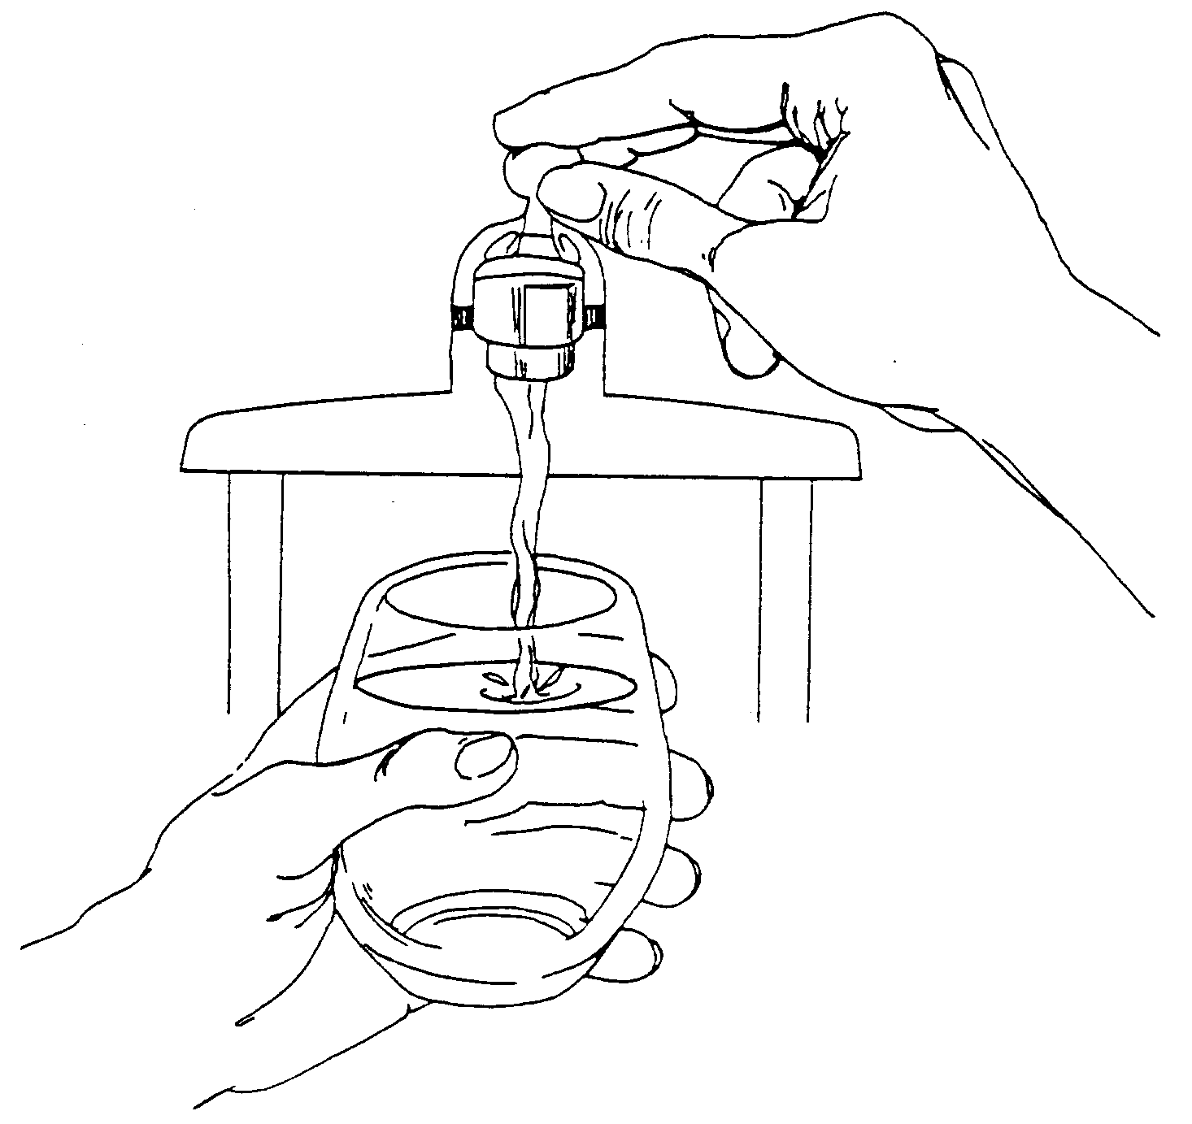
In order to ensure that tap water is safe to drink, the U.S. EPA prescribes regulations that limit the levels of certain contaminants in water provided by public water systems. Federal Food and Drug Administration regulations establish limits for contaminants in bottled water which provide the same protection for public health.

Water Quality Data
The table below lists all the drinking water contaminants that we detected during the 2022 calendar year. The presence of these contaminants in the water does not necessarily indicate that the water poses a health risk. Unless otherwise noted, the data presented in this table is from testing done January 1 through December 31, 2022. The State allows us to monitor for certain contaminants less than once per year because the concentrations of these contaminants are not expected to vary significantly from year to year. All the data is representative of the water quality, but some are more than one year old.

Terms and abbreviations used below:
- Maximum Contaminant Level Goal (MCLG): The level of a contaminant in drinking water below which there is no known or expected risk to health. MCLGs allow for a margin of safety.
- Maximum Contaminant Level (MCL): The highest level of a contaminant that is allowed in drinking water. MCLs are set as close to the MCLGs as feasible using the best available treatment technology.
- Maximum Residual Disinfectant Level (MRDL): The highest level of a disinfectant allowed in drinking water. There is convincing evidence that addition of a disinfectant is necessary for control of microbial contaminants.
- Maximum Residual Disinfectant Level Goal (MRDLG): The level of a drinking water disinfectant below which there is no known or expected risk to health. MRDLGs do not reflect the benefits of the use of disinfectants to control microbial contaminants.
- Treatment Technique (TT): A required process intended to reduce the level of a contaminant in drinking water.
- N/A: Not applicable
- ND: not detectable at testing limit
- ppm: parts per million or milligrams per liter
- ppb: parts per billion or micrograms per liter
- ppt: parts per trillion or nanograms per liter
- pCi/l: picocuries per liter (a measure of radioactivity)
- Action Level (AL): The concentration of a contaminant which, if exceeded, triggers treatment or other requirements that a water system must follow.
- Level 1 Assessment: A study of the water supply to identify potential problems and determine (if possible) why total coliform bacteria have been found in our water system.
- Level 2 Assessment: A very detailed study of the water system to identify potential problems and determine (if possible) why an E. coli MCL violation has occurred and/or why total coliform bacteria have been found in our water system on multiple occasions.

1Monitoring Data for Regulated Contaminants
Regulated Contaminant | MCL, TT, or MRDL | MCLG or MRDLG | Level Detected | Range | Year Sampled | Violation Yes/No | Typical Source of Contaminant
Arsenic (ppb) | 10 | 0 | N/D | N/D | 8/24/15 | NO | Erosion of natural deposits; Runoff from orchards; Runoff from glass and electronics production wastes
Barium (ppm) | 2 | 2 | 0.045 | 0.02-0.07 | 8/24/15 | NO | Discharge of drilling wastes; Discharge of metal refineries; Erosion of natural deposits
Nitrate (ppm) | 10 | 10 | N/D | N/D | 8/8/22 | NO | Runoff from fertilizer use; Leaching from septic tanks, sewage; Erosion of natural deposits
Fluoride (ppm) | 4 | 4 | 1.5 | 1.4-1.6 | 8/8/22 | NO | Erosion of natural deposits; Water additive which promotes strong teeth; Discharge from fertilizer and aluminum factories
Sodium (ppm) | N/A | N/A | 19 | 12-28 | 8/8/22 | NO | Erosion of natural deposits
Sulfate (ppm) | N/A | N/A | 20 | 15-25 | 8/8/22 | NO | Erosion of natural deposits
TTHM Total Trihalomethanes (ppb) | 80 | N/A | .0025 | .0021-.0028 | 2022 | NO | Byproduct of drinking water disinfection
HAA5 Haloacetic Acids (ppb) | 60 | N/A | N/D | N/D | 8/23/22 | NO | Byproduct of drinking water disinfection
Chlorine (ppm) | 4 | 4 | RAA=0.5 mg/L | 0.39-0.67 | Monthly | NO | Water additive used to control microbes
Alpha emitters (pCi/L) | 15 | 0 | 11.0 | 9.54-11.00 | 2022 | NO | Erosion of natural deposits
Combined radium (pCi/L) | 5 | 0 | 3.81 | 3.35-3.81 | 2022 | NO | Erosion of natural deposits

JANUARY 2022 – JUNE 2022
Inorganic Contaminant Subject to Action Levels (AL) | Action Level | MCLG | Your Water | Range of Results | Year Sampled | Number of Samples Above AL | Typical Source of Contaminant
Lead (ppb) | 15 | 0 | 4 | 0 ppb-6 ppb | 2022 | 0 | Lead service lines, corrosion of household plumbing including fittings and fixtures; Erosion of natural deposits
Copper (ppm) | 1.3 | 1.3 | 0.1 | 0.0 ppm-0.1 ppm | 2022 | 0 | Corrosion of household plumbing systems; Erosion of natural deposits

Additional Monitoring
Unregulated contaminants are those for which the U.S. EPA has not established drinking water standards. Monitoring helps the U.S. EPA determine where certain contaminants occur and whether regulation of those contaminants is needed.
Unregulated Contaminant Name | Average Level Detected | Range | Year Sampled | Comments
Calcium | 44 | 39-47 | 2022 | Results of monitoring are available upon request
Chloride | 7 | 6-8 | 2022 | Results of monitoring are available upon request
Iron | 0.19 | 0.17-0.30 | 2022 | Results of monitoring are available upon request
Magnesium | 19 | 17-20 | 2022 | Results of monitoring are available upon request

Information about lead: If present, elevated levels of lead can cause serious health problems, especially for pregnant women and young children. Lead in drinking water is primarily from materials and components associated with service lines and home plumbing. The City of Onaway is responsible for providing high quality drinking water, but cannot control the variety of materials used in plumbing components. When your water has been sitting for several hours, you can minimize the potential for lead exposure by flushing your tap for 30 seconds to 2 minutes before using water for drinking or cooking. If you have a lead service line it is recommended that you run your water for at least 5 minutes to flush water from both your home plumbing and the lead service line. If you are concerned about lead in your water, you may wish to have your water tested. Information on lead in drinking water, testing methods, and steps you can take to minimize exposure is available from the Safe Drinking Water Hotline or at http://www.epa.gov/safewater/lead.
Infants and children who drink water containing lead could experience delays in their physical or mental development. Children could show slight deficits in attention span and learning abilities. Adults who drink this water over many years could develop kidney problems or high blood pressure.
Our water supply has 429 lead service lines and 14 service lines of unknown material out of a total of 492 service lines.
We will update this report annually and will keep you informed of any problems that may occur throughout the year, as they happen. Copies are available at 20774 State Street, Onaway, MI 49765. You can call 989-733-8313 to request a copy of this report. This report will not be sent to you.
We invite public participation in decisions that affect drinking water quality. The Commission meets the first and third Monday at 5:30p.m., at City Hall. For more information about your water, or the contents of this report, contact Andrew Richards or Crystal Veal at 989-733-8313, or by mail at P.O. Box 761, Onaway, MI 49765. For more information about safe drinking water, visit the U.S. EPA at http://www.epa.gov/safewater.

Sodium is not a regulated contaminant.
The chlorine “Level Detected” was calculated using a running annual average.
JULY 2022 – DECEMBER 2022 Inorganic Contaminant Subject to Action Levels (AL) Action Level MCLG Your Water Range of Results Year Sampled Number of Samples Above AL Typical Source of Contaminant Lead (ppb) 15 0 2 0 ppb-4 ppb 2022 0 Lead service lines, corrosion of household plumbing including fittings and fixtures; Erosion of natural deposits Copper (ppm) 1.3 1.3 0.1 0.0 ppm-0.1 ppm 2022 0 Corrosion of household plumbing systems; Erosion of natural deposits 3 Ninety (90) percent of the samples collected were at or below the level reported for our water. ⁴ E. coli MCL violation occurs if: (1) routine and repeat samples total coliform-positive and either is E. coli-positive, or (2) supply fails to take all required repeat samples following E. coli-positive routine sample, or (3) supply fails to analyze total coliform-positive repeat sample for E. coli.

